**TASK 1:**

#include <stdio.h>

int main() {

    char ch;

    printf("Enter the Character: ");

    scanf("%s",&ch);

    if(ch=='a' || ch=='e' || ch=='i' || ch=='o' || ch=='u' || ch=='A' || ch=='E' || ch=='I' || ch=='O' || ch=='U'){

        printf("This is a vowel");

    }

    else if((ch>='a' && ch<='z') || (ch>='A' && ch<='Z')){

            printf("This is a consonant");

    }

    else{

        printf("This is not a character");

    }

    return 0;

}

**FLOWCHART:**

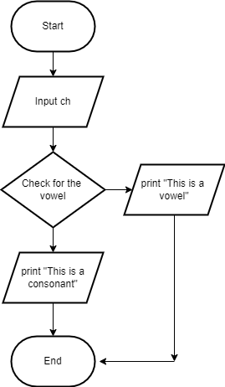

**TASK 2:**

#include <stdio.h>

int main() {

    double income, tax = 0.0, net_income;

    printf("Enter your total income: ");

    scanf("%lf", &income);

    if (income <= 250000) {

        tax = 0.0;

    } else if (income <= 500000) {

        tax = (income - 250000) * 0.05;

    } else if (income <= 1000000) {

        tax = (250000 * 0.05) + (income - 500000) * 0.20;

    } else {

        tax = (250000 * 0.05) + (500000 * 0.20) + (income - 1000000) * 0.30;}

    net_income = income - tax;

    printf("Total income: %.2lf\n", income);

    printf("Tax amount: %.2lf\n", tax);

    printf("Net income after tax: %.2lf\n", net_income);

    return 0;

}

**FLOWCHARTS:**

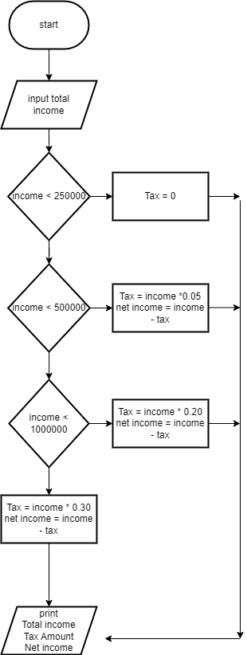

**TASK 3:**

#include<stdio.h>

int main(){

    int year;

    printf("Enter The Year: ");

    scanf("%d",&year);

    if((year%4==0 && year%100!=0) || year%400==0){

        printf("Hurray! This is a Leap Year");

    }

    else{

        printf("This is not a leap  year");

    }

    return 0;

}

**FlOWCHART:**

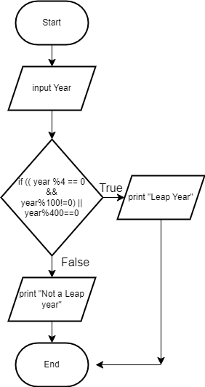

**TASK 4:**

#include<stdio.h>

int main(){

    int marks;

    printf("Enter Your Marks: ");

    scanf("%d",&marks );

    if(marks>=90){

        printf("Grade: A1");

    }

    else if(marks>=80 && marks<90){

        printf("Grade: A");

    }

    else if(marks>=70 && marks<80){

        printf("Grade: B");

    }

    else if(marks>=60 && marks<70){

        printf("Grade: C");

    }

    else if(marks>=50 && marks<60){

        printf("Grade: D");

    }

    else{

        printf("Grade: F");

    }

    return 0;

}

**FLOWCHART:**

